
The Work Number® from Equifax securely and instantly
provides automated income and employment verifications…
to keep your life moving!

Life just got easier with

The Work Number.



  BUYING A HOME  OR REFINANCING? |   RENTING  A PROPERTY? |  |   BUYING  A CAR?
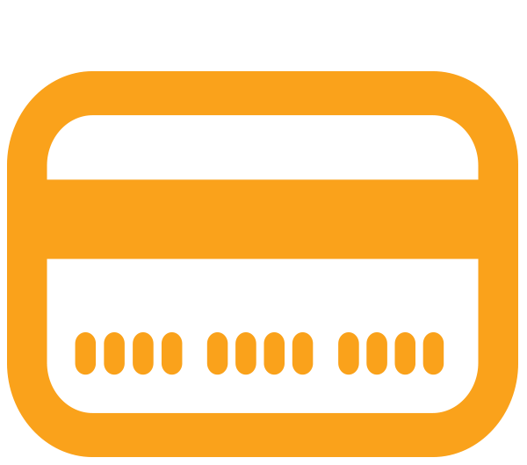  APPLYING FOR A  LOAN OR CREDIT? |  |   QUALIFYING FOR  GOVERNMENT BENEFITS?
If the answer is yes to any of these, The Work Number can streamline
the employment and income verification process.
If you are asked for proof of your employment or income,
please follow these simple steps:
  Your employer code:  50034 |   Your Social Security  Number |   Direct them to:  www.theworknumber.com

